**1 зад.**

Разглеждаме файла Stpsale от библиотека Stpsamp. Изведете съдържанието на този файл. Запаметете го в библиотеката **WORK**. Сортирайте данните по дадена променлива. Направете честотни таблици и ги визуализирайте.

*Показваме съдържанието на файла* ***STPSALE*** *от библиотеката* ***STPSAMP****:*

**proc** **contents** data=STPSAMP.stpsale;

**run**;

*Запаметяваме файла в библиотеката* ***WORK****, за да работим с него:*

**data** work.mysales;

**set** STPSAMP.stpsale;

**run**;

*Показваме съдържанието на файла* ***mysales*** *от библиотеката* ***work****:*

**proc contents** data=work.mysales;

**run**;

*Сортираме данните по количество:*

**proc sort** data=work.mysales;

**by** quantity;

**run**;

**proc** **print** data=work.mysales;

**run**;

| **Obs** | **region** | **citysize** | **pop** | **product** | **saletype** | **quantity** | **amount** |
| --- | --- | --- | --- | --- | --- | --- | --- |
| 1 | NC | S | 25000 | A100 | R | 150 | 3750 |
| 2 | NC | S | 25000 | A100 | W | 150 | 3000 |
| 3 | NC | S | 25000 | A300 | R | 157 | 3925 |
| 4 | NC | S | 25000 | A300 | W | 157 | 3140 |
| 5 | NC | S | 25000 | A200 | R | 165 | 4125 |
| 6 | NC | S | 25000 | A200 | W | 165 | 3300 |
| 7 | WE | S | 32000 | A100 | R | 180 | 4500 |
| 8 | WE | S | 32000 | A100 | W | 180 | 3600 |
| 9 | WE | S | 32000 | A300 | R | 186 | 4650 |
| 10 | WE | S | 32000 | A300 | W | 186 | 3720 |
| 11 | WE | S | 32000 | A200 | R | 195 | 4875 |
| 12 | WE | S | 32000 | A200 | W | 195 | 3900 |
| 13 | NE | S | 37000 | A100 | R | 200 | 5000 |
| 14 | NE | S | 37000 | A100 | W | 200 | 4000 |
| 15 | NE | S | 37000 | A300 | R | 208 | 5200 |
| 16 | NE | S | 37000 | A300 | W | 208 | 4160 |
| 17 | NE | S | 37000 | A200 | R | 215 | 5375 |
| 18 | NE | S | 37000 | A200 | W | 215 | 4300 |
| 19 | NC | M | 125000 | A100 | R | 350 | 8750 |
| 20 | NC | M | 125000 | A100 | W | 350 | 7000 |
| 21 | NC | M | 125000 | A300 | R | 351 | 8725 |
| 22 | NC | M | 125000 | A300 | W | 351 | 7020 |
| 23 | NC | M | 125000 | A200 | R | 365 | 9125 |
| 24 | NC | M | 125000 | A200 | W | 365 | 7300 |
| 25 | SO | S | 48000 | A100 | R | 410 | 10250 |
| 26 | SO | S | 48000 | A300 | R | 419 | 10475 |
| 27 | SO | S | 48000 | A200 | R | 425 | 10425 |
| 28 | NE | M | 237000 | A100 | R | 600 | 15000 |
| 29 | NE | M | 237000 | A100 | W | 600 | 12000 |
| 30 | NE | M | 237000 | A300 | R | 610 | 15250 |
| 31 | NE | M | 237000 | A300 | W | 610 | 12200 |
| 32 | NE | M | 237000 | A200 | R | 615 | 15375 |
| 33 | NE | M | 237000 | A200 | W | 615 | 12300 |
| 34 | SO | M | 348000 | A100 | R | 710 | 17750 |
| 35 | SO | M | 348000 | A100 | W | 710 | 14200 |
| 36 | SO | M | 348000 | A300 | R | 714 | 17850 |
| 37 | SO | M | 348000 | A300 | W | 714 | 14280 |
| 38 | SO | M | 348000 | A200 | R | 725 | 19125 |
| 39 | SO | M | 348000 | A200 | W | 725 | 14500 |
| 40 | NC | L | 625000 | A100 | W | 750 | 15000 |
| 41 | NC | L | 625000 | A300 | W | 757 | 15140 |
| 42 | SO | L | 748000 | A100 | R | 760 | 19000 |
| 43 | SO | L | 748000 | A100 | W | 760 | 15200 |
| 44 | NC | L | 625000 | A200 | W | 765 | 15300 |
| 45 | SO | L | 748000 | A300 | R | 768 | 19200 |
| 46 | SO | L | 748000 | A300 | W | 768 | 15360 |
| 47 | SO | L | 748000 | A200 | R | 775 | 19375 |
| 48 | SO | L | 748000 | A200 | W | 775 | 15500 |
| 49 | WE | M | 432000 | A100 | R | 780 | 19500 |
| 50 | WE | M | 432000 | A100 | W | 780 | 15600 |
| 51 | WE | M | 432000 | A300 | R | 785 | 19625 |
| 52 | WE | M | 432000 | A300 | W | 785 | 15700 |
| 53 | WE | M | 432000 | A200 | R | 795 | 19875 |
| 54 | WE | M | 432000 | A200 | W | 795 | 15900 |
| 55 | NE | L | 837000 | A100 | R | 800 | 20000 |
| 56 | NE | L | 837000 | A100 | W | 800 | 16000 |
| 57 | NE | L | 837000 | A300 | R | 806 | 20150 |
| 58 | NE | L | 837000 | A300 | W | 806 | 16120 |
| 59 | NE | L | 837000 | A200 | R | 815 | 20375 |
| 60 | NE | L | 837000 | A200 | W | 815 | 16300 |
| 61 | WE | L | 932000 | A100 | R | 880 | 22000 |
| 62 | WE | L | 932000 | A100 | W | 880 | 17600 |
| 63 | WE | L | 932000 | A300 | R | 880 | 22000 |
| 64 | WE | L | 932000 | A300 | W | 880 | 17600 |
| 65 | WE | L | 932000 | A200 | R | 895 | 22375 |
| 66 | WE | L | 932000 | A200 | W | 895 | 17900 |

*Създаваме цялостна честотна таблица:*

**proc** **freq** data=mysales;

**run**;

**The FREQ Procedure**

| **region** | **Frequency** | **Percent** | **Cumulative Frequency** | **Cumulative Percent** |
| --- | --- | --- | --- | --- |
| NC | 15 | 22.73 | 15 | 22.73 |
| NE | 18 | 27.27 | 33 | 50.00 |
| SO | 15 | 22.73 | 48 | 72.73 |
| WE | 18 | 27.27 | 66 | 100.00 |

| **citysize** | **Frequency** | **Percent** | **Cumulative Frequency** | **Cumulative Percent** |
| --- | --- | --- | --- | --- |
| L | 21 | 31.82 | 21 | 31.82 |
| M | 24 | 36.36 | 45 | 68.18 |
| S | 21 | 31.82 | 66 | 100.00 |

| **pop** | **Frequency** | **Percent** | **Cumulative Frequency** | **Cumulative Percent** |
| --- | --- | --- | --- | --- |
| 25000 | 6 | 9.09 | 6 | 9.09 |
| 32000 | 6 | 9.09 | 12 | 18.18 |
| 37000 | 6 | 9.09 | 18 | 27.27 |
| 48000 | 3 | 4.55 | 21 | 31.82 |
| 125000 | 6 | 9.09 | 27 | 40.91 |
| 237000 | 6 | 9.09 | 33 | 50.00 |
| 348000 | 6 | 9.09 | 39 | 59.09 |
| 432000 | 6 | 9.09 | 45 | 68.18 |
| 625000 | 3 | 4.55 | 48 | 72.73 |
| 748000 | 6 | 9.09 | 54 | 81.82 |
| 837000 | 6 | 9.09 | 60 | 90.91 |
| 932000 | 6 | 9.09 | 66 | 100.00 |

.

.

.

.

*Създаваме две честотни таблици за променливите регион и размер на града:*

**proc** **freq** data=mysales;

tables region citysize;

**run**;

**The FREQ Procedure**

| **region** | **Frequency** | **Percent** | **Cumulative Frequency** | **Cumulative Percent** |
| --- | --- | --- | --- | --- |
| NC | 15 | 22.73 | 15 | 22.73 |
| NE | 18 | 27.27 | 33 | 50.00 |
| SO | 15 | 22.73 | 48 | 72.73 |
| WE | 18 | 27.27 | 66 | 100.00 |

| **citysize** | **Frequency** | **Percent** | **Cumulative Frequency** | **Cumulative Percent** |
| --- | --- | --- | --- | --- |
| L | 21 | 31.82 | 21 | 31.82 |
| M | 24 | 36.36 | 45 | 68.18 |
| S | 21 | 31.82 | 66 | 100.00 |

*Създаваме една двумерна честотна таблица за двете променливи:*

**proc** **freq** data=mysales;

tables region *citysize;

**run**;

**The FREQ Procedure**

| **Table of region by citysize** | | | | | |
| --- | --- | --- | --- | --- | --- |
|  | | **citysize** | | | **Total** |
| **L** | **M** | **S** |
| **region** |  | 3 | 6 | 6 | 15 |
| **NC** | **Frequency** |
| **Percent** | 4.55 | 9.09 | 9.09 | 22.73 |
| **Row Pct** | 20.00 | 40.00 | 40.00 |  |
| **Col Pct** | 14.29 | 25.00 | 28.57 |  |
| **NE** | **Frequency** | 6 | 6 | 6 | 18 |
| **Percent** | 9.09 | 9.09 | 9.09 | 27.27 |
| **Row Pct** | 33.33 | 33.33 | 33.33 |  |
| **Col Pct** | 28.57 | 25.00 | 28.57 |  |
| **SO** | **Frequency** | 6 | 6 | 3 | 15 |
| **Percent** | 9.09 | 9.09 | 4.55 | 22.73 |
| **Row Pct** | 40.00 | 40.00 | 20.00 |  |
| **Col Pct** | 28.57 | 25.00 | 14.29 |  |
| **WE** | **Frequency** | 6 | 6 | 6 | 18 |
| **Percent** | 9.09 | 9.09 | 9.09 | 27.27 |
| **Row Pct** | 33.33 | 33.33 | 33.33 |  |
| **Col Pct** | 28.57 | 25.00 | 28.57 |  |
|  |  | 21 | 24 | 21 | 66 |
| **Total** | **Frequency** |
| **Percent** | 31.82 | 36.36 | 31.82 | 100.00 |

*Създаваме тримерна честотна таблица за 3 променливи:*

**proc** **freq** data=mysales;

tables region *citysize*saletype;

**run**;

|  |  |  |  |  |  |  |  |  |  |  |  |  |  |  |  |  |  |  |  |  |  |  |  |  |  |  |  |  |  |  |  |  |  |  |  |  |  |  |  |  |  |  |  |  |  |  |  |  |  |  |  |  |  |  |  |  |  |  |  |  |  |  |  |  |  |  |  |  |  |  |  |  |  |  |  |  |  |  |  |  |  |  |  |  |  |  |  |  |  |  |  |  |  |  |  |  |  |  |  |  |  |  |  |  |  |  |  |  |  |  |  |  |  |  |  |  |  |  |  |  |  |  |  |  |  |  |  |  |  |  |  |  |  |  |  |  |  |  |  |  |  |  |  |  |  |  |  |  |  |  |  |  |  |  |  |  |  |  |  |  |  |  |  |  |  |  |  |  |  |  |  |  |  |  |  |  |  |  |  |  |  |  |  |  |  |  |  |  |  |  |  |  |  |  |  |  |  |  |  |  |  |  |  |  |  |  |  |  |  |  |  |  |  |  |  |  |  |  |  |  |  |  |  |  |  |  |  |  |  |  |  |  |  |  |  |  |  |  |  |  |  |  |  |  |  |  |  |  |  |  |  |  |  |  |  |  |  |  |  |  |  |  |  |  |  |  |  |  |  |  |  |  |  |  |  |  |  |  |  |  |  |  |  |  |  |  |  |  |  |  |  |  |  |  |  |  |  |  |  |  |  |  |  |  |  |  |  |  |  |  |  |  |  |  |  |  |  |  |  |  |  |  |  |  |  |  |  |  |  |  |  |  |  |
| --- | --- | --- | --- | --- | --- | --- | --- | --- | --- | --- | --- | --- | --- | --- | --- | --- | --- | --- | --- | --- | --- | --- | --- | --- | --- | --- | --- | --- | --- | --- | --- | --- | --- | --- | --- | --- | --- | --- | --- | --- | --- | --- | --- | --- | --- | --- | --- | --- | --- | --- | --- | --- | --- | --- | --- | --- | --- | --- | --- | --- | --- | --- | --- | --- | --- | --- | --- | --- | --- | --- | --- | --- | --- | --- | --- | --- | --- | --- | --- | --- | --- | --- | --- | --- | --- | --- | --- | --- | --- | --- | --- | --- | --- | --- | --- | --- | --- | --- | --- | --- | --- | --- | --- | --- | --- | --- | --- | --- | --- | --- | --- | --- | --- | --- | --- | --- | --- | --- | --- | --- | --- | --- | --- | --- | --- | --- | --- | --- | --- | --- | --- | --- | --- | --- | --- | --- | --- | --- | --- | --- | --- | --- | --- | --- | --- | --- | --- | --- | --- | --- | --- | --- | --- | --- | --- | --- | --- | --- | --- | --- | --- | --- | --- | --- | --- | --- | --- | --- | --- | --- | --- | --- | --- | --- | --- | --- | --- | --- | --- | --- | --- | --- | --- | --- | --- | --- | --- | --- | --- | --- | --- | --- | --- | --- | --- | --- | --- | --- | --- | --- | --- | --- | --- | --- | --- | --- | --- | --- | --- | --- | --- | --- | --- | --- | --- | --- | --- | --- | --- | --- | --- | --- | --- | --- | --- | --- | --- | --- | --- | --- | --- | --- | --- | --- | --- | --- | --- | --- | --- | --- | --- | --- | --- | --- | --- | --- | --- | --- | --- | --- | --- | --- | --- | --- | --- | --- | --- | --- | --- | --- | --- | --- | --- | --- | --- | --- | --- | --- | --- | --- | --- | --- | --- | --- | --- | --- | --- | --- | --- | --- | --- | --- | --- | --- | --- | --- | --- | --- | --- | --- | --- | --- | --- | --- | --- | --- | --- | --- | --- | --- | --- | --- | --- | --- | --- | --- | --- | --- | --- | --- | --- | --- | --- | --- | --- | --- | --- | --- | --- | --- | --- | --- | --- | --- | --- | --- | --- | --- | --- | --- | --- | --- | --- |
| |  |  |  |  |  |  |  |  |  |  |  |  |  |  |  |  |  |  |  |  |  |  |  |  |  |  |  |  |  |  |  |  |  |  |  |  |  |  |  |  |  |  |  |  |  |  |  |  |  |  |  |  |  |  |  |  |  |  |  |  |  |  |  |  |  |  |  |  |  |  |  |  |  |  |  |  |  |  |  |  |  |  |  |  |  |  |  |  |  |  |  |  |  |  |  |  |  |  |  |  |  |  |  |  |  |  |  |  |  |  |  |  |  |  |  |  |  |  |  |  |  |  |  |  |  |  |  |  |  |  |  |  |  |  |  |  |  |  |  |  |  |  |  |  |  |  |  |  |  |  |  |  |  |  |  |  |  |  |  |  |  |  |  |  |  |  |  |  |  |  |  |  |  |  |  |  |  |  |  |  |  |  |  |  |  |  |  |  |  |  |  |  |  |  |  |  |  |  |  |  |  |  |  |  |  |  |  |  |  |  |  |  |  |  |  |  |  |  |  |  |  |  |  |  |  |  |  |  |  |  |  |  |  |  |  |  |  |  |  |  |  |  |  |  |  |  |  |  |  |  |  |  |  |  |  |  |  |  |  |  |  |  |  |  |  |  |  |  |  |  |  |  |  |  |  |  |  |  |  |  |  |  |  |  |  |  |  |  |  |  |  |  |  |  |  |  |  |  |  |  |  |  |  |  |  |  |  |  |  |  |  |  |  |  |  |  |  |  |  |  |  |  |  |  |  |  |  |  |  |  |  |  |  | | --- | --- | --- | --- | --- | --- | --- | --- | --- | --- | --- | --- | --- | --- | --- | --- | --- | --- | --- | --- | --- | --- | --- | --- | --- | --- | --- | --- | --- | --- | --- | --- | --- | --- | --- | --- | --- | --- | --- | --- | --- | --- | --- | --- | --- | --- | --- | --- | --- | --- | --- | --- | --- | --- | --- | --- | --- | --- | --- | --- | --- | --- | --- | --- | --- | --- | --- | --- | --- | --- | --- | --- | --- | --- | --- | --- | --- | --- | --- | --- | --- | --- | --- | --- | --- | --- | --- | --- | --- | --- | --- | --- | --- | --- | --- | --- | --- | --- | --- | --- | --- | --- | --- | --- | --- | --- | --- | --- | --- | --- | --- | --- | --- | --- | --- | --- | --- | --- | --- | --- | --- | --- | --- | --- | --- | --- | --- | --- | --- | --- | --- | --- | --- | --- | --- | --- | --- | --- | --- | --- | --- | --- | --- | --- | --- | --- | --- | --- | --- | --- | --- | --- | --- | --- | --- | --- | --- | --- | --- | --- | --- | --- | --- | --- | --- | --- | --- | --- | --- | --- | --- | --- | --- | --- | --- | --- | --- | --- | --- | --- | --- | --- | --- | --- | --- | --- | --- | --- | --- | --- | --- | --- | --- | --- | --- | --- | --- | --- | --- | --- | --- | --- | --- | --- | --- | --- | --- | --- | --- | --- | --- | --- | --- | --- | --- | --- | --- | --- | --- | --- | --- | --- | --- | --- | --- | --- | --- | --- | --- | --- | --- | --- | --- | --- | --- | --- | --- | --- | --- | --- | --- | --- | --- | --- | --- | --- | --- | --- | --- | --- | --- | --- | --- | --- | --- | --- | --- | --- | --- | --- | --- | --- | --- | --- | --- | --- | --- | --- | --- | --- | --- | --- | --- | --- | --- | --- | --- | --- | --- | --- | --- | --- | --- | --- | --- | --- | --- | --- | --- | --- | --- | --- | --- | --- | --- | --- | --- | --- | --- | --- | --- | --- | --- | --- | --- | --- | --- | --- | --- | --- | --- | --- | --- | --- | --- | --- | --- | --- | --- | --- | --- | --- | --- | --- | --- | --- | --- | --- | --- | --- | --- | --- | --- | | |  |  |  |  |  |  |  |  |  |  |  |  |  |  |  |  |  |  |  |  |  |  |  |  |  |  |  |  |  |  |  |  |  |  |  |  |  |  |  |  |  |  |  |  |  |  |  |  |  |  |  |  |  |  |  |  |  |  |  |  |  |  |  |  |  |  |  |  |  |  |  |  |  |  |  |  |  |  |  |  |  |  |  |  |  |  |  |  |  |  |  |  |  |  |  |  |  |  |  |  |  |  |  |  |  |  |  |  |  |  |  |  |  |  |  |  |  |  |  |  |  |  |  |  |  |  |  |  |  |  |  |  |  |  |  |  |  |  |  |  |  |  |  |  |  |  |  |  |  |  |  |  |  |  |  |  |  |  |  |  |  |  |  |  |  |  |  |  |  |  |  |  |  |  |  |  |  |  |  |  |  |  |  |  |  |  |  |  |  |  |  |  |  |  |  |  |  |  |  |  |  |  |  |  |  |  |  |  |  |  |  |  |  |  |  |  |  |  |  |  |  |  |  |  |  |  |  |  |  |  |  |  |  |  |  |  |  |  |  |  |  |  |  |  |  |  |  |  |  |  |  |  |  |  |  |  |  |  |  |  |  |  |  |  |  |  |  |  |  |  |  |  |  |  |  |  |  |  |  |  |  |  |  |  |  |  |  |  |  |  |  |  |  |  |  |  |  |  |  |  |  |  |  |  |  |  |  |  |  |  |  |  |  |  |  |  |  |  |  |  |  |  |  |  |  |  |  |  |  |  |  |  | | --- | --- | --- | --- | --- | --- | --- | --- | --- | --- | --- | --- | --- | --- | --- | --- | --- | --- | --- | --- | --- | --- | --- | --- | --- | --- | --- | --- | --- | --- | --- | --- | --- | --- | --- | --- | --- | --- | --- | --- | --- | --- | --- | --- | --- | --- | --- | --- | --- | --- | --- | --- | --- | --- | --- | --- | --- | --- | --- | --- | --- | --- | --- | --- | --- | --- | --- | --- | --- | --- | --- | --- | --- | --- | --- | --- | --- | --- | --- | --- | --- | --- | --- | --- | --- | --- | --- | --- | --- | --- | --- | --- | --- | --- | --- | --- | --- | --- | --- | --- | --- | --- | --- | --- | --- | --- | --- | --- | --- | --- | --- | --- | --- | --- | --- | --- | --- | --- | --- | --- | --- | --- | --- | --- | --- | --- | --- | --- | --- | --- | --- | --- | --- | --- | --- | --- | --- | --- | --- | --- | --- | --- | --- | --- | --- | --- | --- | --- | --- | --- | --- | --- | --- | --- | --- | --- | --- | --- | --- | --- | --- | --- | --- | --- | --- | --- | --- | --- | --- | --- | --- | --- | --- | --- | --- | --- | --- | --- | --- | --- | --- | --- | --- | --- | --- | --- | --- | --- | --- | --- | --- | --- | --- | --- | --- | --- | --- | --- | --- | --- | --- | --- | --- | --- | --- | --- | --- | --- | --- | --- | --- | --- | --- | --- | --- | --- | --- | --- | --- | --- | --- | --- | --- | --- | --- | --- | --- | --- | --- | --- | --- | --- | --- | --- | --- | --- | --- | --- | --- | --- | --- | --- | --- | --- | --- | --- | --- | --- | --- | --- | --- | --- | --- | --- | --- | --- | --- | --- | --- | --- | --- | --- | --- | --- | --- | --- | --- | --- | --- | --- | --- | --- | --- | --- | --- | --- | --- | --- | --- | --- | --- | --- | --- | --- | --- | --- | --- | --- | --- | --- | --- | --- | --- | --- | --- | --- | --- | --- | --- | --- | --- | --- | --- | --- | --- | --- | --- | --- | --- | --- | --- | --- | --- | --- | --- | --- | --- | --- | --- | --- | --- | --- | --- | --- | --- | --- | --- | --- | --- | --- | --- | --- | | |  |  | | --- | --- | | |  | | --- | | **The FREQ Procedure** | | | |  |  |  |  |  |  |  |  |  |  |  |  |  |  |  |  |  |  |  |  |  |  |  |  |  |  |  |  |  |  |  |  |  |  |  |  |  |  |  |  |  |  |  |  |  |  |  |  |  |  |  |  |  |  |  |  |  |  |  |  |  |  |  |  |  |  |  |  |  |  |  |  |  |  |  |  |  |  |  |  |  |  | | --- | --- | --- | --- | --- | --- | --- | --- | --- | --- | --- | --- | --- | --- | --- | --- | --- | --- | --- | --- | --- | --- | --- | --- | --- | --- | --- | --- | --- | --- | --- | --- | --- | --- | --- | --- | --- | --- | --- | --- | --- | --- | --- | --- | --- | --- | --- | --- | --- | --- | --- | --- | --- | --- | --- | --- | --- | --- | --- | --- | --- | --- | --- | --- | --- | --- | --- | --- | --- | --- | --- | --- | --- | --- | --- | --- | --- | --- | --- | --- | --- | --- | | | **Table 1 of citysize by saletype** | | | | | | --- | --- | --- | --- | --- | | **Controlling for region=NC** | | | | | |  | | **saletype** | | **Total** | | **R** | **W** | | **citysize** |  | 0 | 3 | 3 | | **L** | **Frequency** | | **Percent** | 0.00 | 20.00 | 20.00 | | **Row Pct** | 0.00 | 100.00 |  | | **Col Pct** | 0.00 | 33.33 |  | | **M** | **Frequency** | 3 | 3 | 6 | | **Percent** | 20.00 | 20.00 | 40.00 | | **Row Pct** | 50.00 | 50.00 |  | | **Col Pct** | 50.00 | 33.33 |  | | **S** | **Frequency** | 3 | 3 | 6 | | **Percent** | 20.00 | 20.00 | 40.00 | | **Row Pct** | 50.00 | 50.00 |  | | **Col Pct** | 50.00 | 33.33 |  | |  |  | 6 | 9 | 15 | | **Total** | **Frequency** | | **Percent** | 40.00 | 60.00 | 100.00 | | | | **Table 2 of citysize by saletype** | | | | | | --- | --- | --- | --- | --- | | **Controlling for region=NE** | | | | | |  | | **saletype** | | **Total** | | **R** | **W** | | **citysize** |  | 3 | 3 | 6 | | **L** | **Frequency** | | **Percent** | 16.67 | 16.67 | 33.33 | | **Row Pct** | 50.00 | 50.00 |  | | **Col Pct** | 33.33 | 33.33 |  | | **M** | **Frequency** | 3 | 3 | 6 | | **Percent** | 16.67 | 16.67 | 33.33 | | **Row Pct** | 50.00 | 50.00 |  | | **Col Pct** | 33.33 | 33.33 |  | | **S** | **Frequency** | 3 | 3 | 6 | | **Percent** | 16.67 | 16.67 | 33.33 | | **Row Pct** | 50.00 | 50.00 |  | | **Col Pct** | 33.33 | 33.33 |  | |  |  | 9 | 9 | 18 | | **Total** | **Frequency** | | **Percent** | 50.00 | 50.00 | 100.00 | | | | **Table 3 of citysize by saletype** | | | | | | --- | --- | --- | --- | --- | | **Controlling for region=SO** | | | | | |  | | **saletype** | | **Total** | | **R** | **W** | | **citysize** |  | 3 | 3 | 6 | | **L** | **Frequency** | | **Percent** | 20.00 | 20.00 | 40.00 | | **Row Pct** | 50.00 | 50.00 |  | | **Col Pct** | 33.33 | 50.00 |  | | **M** | **Frequency** | 3 | 3 | 6 | | **Percent** | 20.00 | 20.00 | 40.00 | | **Row Pct** | 50.00 | 50.00 |  | | **Col Pct** | 33.33 | 50.00 |  | | **S** | **Frequency** | 3 | 0 | 3 | | **Percent** | 20.00 | 0.00 | 20.00 | | **Row Pct** | 100.00 | 0.00 |  | | **Col Pct** | 33.33 | 0.00 |  | |  |  | 9 | 6 | 15 | | **Total** | **Frequency** | | **Percent** | 60.00 | 40.00 | 100.00 | | | | **Table 4 of citysize by saletype** | | | | | | --- | --- | --- | --- | --- | | **Controlling for region=WE** | | | | | |  | | **saletype** | | **Total** | | **R** | **W** | | **citysize** |  | 3 | 3 | 6 | | **L** | **Frequency** | | **Percent** | 16.67 | 16.67 | 33.33 | | **Row Pct** | 50.00 | 50.00 |  | | **Col Pct** | 33.33 | 33.33 |  | | **M** | **Frequency** | 3 | 3 | 6 | | **Percent** | 16.67 | 16.67 | 33.33 | | **Row Pct** | 50.00 | 50.00 |  | | **Col Pct** | 33.33 | 33.33 |  | | **S** | **Frequency** | 3 | 3 | 6 | | **Percent** | 16.67 | 16.67 | 33.33 | | **Row Pct** | 50.00 | 50.00 |  | | **Col Pct** | 33.33 | 33.33 |  | |  |  | 9 | 9 | 18 | | **Total** | **Frequency** | | **Percent** | 50.00 | 50.00 | 100.00 | | | | | |

*Със следващата команда отпечатваме таблица и групираме количествени и качествени променливи и извеждане на средното и стандартното отклонение:*

**proc** **tabulate** data=work.mysales;

class region;

var quantity amount;

table region * (quantity amount), mean std;

**run**;

|  | | **Mean** | **Std** |
| --- | --- | --- | --- |
| **region** |  | 356.53 | 226.88 |
| **NC** | **quantity** |
| **amount** | 7640.00 | 4444.28 |
| **NE** | **quantity** | 541.00 | 256.57 |
| **amount** | 12172.50 | 5972.79 |
| **SO** | **quantity** | 677.20 | 136.39 |
| **amount** | 15499.33 | 3246.29 |
| **WE** | **quantity** | 619.56 | 317.50 |
| **amount** | 13940.00 | 7362.30 |

**2 зад**.

Създайте ваш файл и въведете данни. Въведете заглавие на дадена таблица. Въведете нова колона в таблица. Изведете данните със следните условия:  
1) if...then  
 else if...then  
2) when  
Операторът- OR  
Операторът-Wherе

**data** results;

length Gender $ **1**

Quiz $ **2**;

input Age Gender$ Midterm Quiz $ FinalExam;

if Age < **20** and not missing(age) then AgeGroup=**1**;

else if Age >= **20** and Age < **40** then AgeGroup=**2**;

else if Age >= **40** and Age < **60** then AgeGroup=**3**;

else if Age >= **60** then AgeGroup=**4**;

datalines;

21 M 80 B- 82

. F 90 A 93

35 M 87 B+ 85

48 F . . 76

59 F 95 A+ 97

15 M 88 . 93

67 F 97 A 91

. M 62 F 67

35 F 77 C- 77

49 M 59 C 81

;

title "Listing of RESULTS";

**proc** **print** data=results noobs;

**run**;

**Listing of RESULTS**

| **Gender** | **Quiz** | **Age** | **Midterm** | **FinalExam** | **AgeGroup** |
| --- | --- | --- | --- | --- | --- |
| M | B- | 21 | 80 | 82 | 2 |
| F | A | . | 90 | 93 | . |
| M | B+ | 35 | 87 | 85 | 2 |
| F |  | 48 | . | 76 | 3 |
| F | A+ | 59 | 95 | 97 | 3 |
| M |  | 15 | 88 | 93 | 1 |
| F | A | 67 | 97 | 91 | 4 |
| M | F | . | 62 | 67 | . |
| F | C- | 35 | 77 | 77 | 2 |
| M | C | 49 | 59 | 81 | 3 |

*Същите данни само от женски пол:*

**data** females;

length Gender $**1**

Quiz $**2**;

input Age Gender Midterm Quiz FinalExam;

if Gender eq 'F';

datalines;

21 M 80 B- 82

. F 90 A 93

35 M 87 B+ 85

48 F . . 76

59 F 95 A+ 97

15 M 88 . 93

67 F 97 A 91

. M 62 F 67

35 F 77 C- 77

49 M 59 C 81

;

title " Listing of FEMALES";

**proc** **print** data=Females noobs;

**run**;

**Listing of FEMALES**

| **Gender** | **Quiz** | **Age** | **Midterm** | **FinalExam** |
| --- | --- | --- | --- | --- |
| F | A | . | 90 | 93 |
| F |  | 48 | . | 76 |
| F | A+ | 59 | 95 | 97 |
| F | A | 67 | 97 | 91 |
| F | C- | 35 | 77 | 77 |

*Нова колона въвеждаме:*

**data** females;

length Gender $**1**

Quiz $ **2**;

input Age Gender Midterm Quiz FinalExam;

if Quiz='A+' or Quiz='A' or Quiz='B+' or Quiz='B'

then QuizRange=**1**;

else if Quiz='B-' or Quiz='C+' or Quiz='C'

then QuizRange=**2**;

else if not missing(Quiz) then QuizRange=**3**;

datalines;

21 M 80 B- 82

. F 90 A 93

35 M 87 B+ 85

48 F . . 76

59 F 95 A+ 97

15 M 88 . 93

67 F 97 A 91

. M 62 F 67

35 F 77 C- 77

49 M 59 C 81

;

title "Listing of FEMALES";

**proc** **print** data=Females noobs;

**run**;

**Listing of FEMALES**

| **Gender** | **Quiz** | **Age** | **Midterm** | **FinalExam** | **QuizRange** |
| --- | --- | --- | --- | --- | --- |
| M | B- | 21 | 80 | 82 | 2 |
| F | A | . | 90 | 93 | 1 |
| M | B+ | 35 | 87 | 85 | 1 |
| F |  | 48 | . | 76 | . |
| F | A+ | 59 | 95 | 97 | 1 |
| M |  | 15 | 88 | 93 | . |
| F | A | 67 | 97 | 91 | 1 |
| M | F | . | 62 | 67 | 3 |
| F | C- | 35 | 77 | 77 | 3 |
| M | C | 49 | 59 | 81 | 2 |

*Условие WHEN:*

**data** results;

length Gender $**1**

Quiz $**2**;

input Age Gender Midterm Quiz FinalExam;

select;

when(missing (Age)) AgeGroup=**.**;

when(Age < **20**) AgeGroup=**1**;

when(Age<**40**) AgeGroup=**2**;

when(Age<**60**)AgeGroup=**3**;

when(Age >= **60**) AgeGroup=**4**;

otherwise;

end;

datalines;

21 M 80 B- 82

. F 90 A 93

35 M 87 B+ 85

48 F . . 76

59 F 95 A+ 97

15 M 88 . 93

67 F 97 A 91

. M 62 F 67

35 F 77 C- 77

49 M 59 C 81

;

title"Listing of Females";

**proc** **print** data=results noobs;

**run**;

**Listing of Females**

| **Gender** | **Quiz** | **Age** | **Midterm** | **FinalExam** | **AgeGroup** |
| --- | --- | --- | --- | --- | --- |
| M | B- | 21 | 80 | 82 | 2 |
| F | A | . | 90 | 93 | . |
| M | B+ | 35 | 87 | 85 | 2 |
| F |  | 48 | . | 76 | 3 |
| F | A+ | 59 | 95 | 97 | 3 |
| M |  | 15 | 88 | 93 | 1 |
| F | A | 67 | 97 | 91 | 4 |
| M | F | . | 62 | 67 | . |
| F | C- | 35 | 77 | 77 | 2 |
| M | C | 49 | 59 | 81 | 3 |

*Оператор OR:*

**data** believe_it_or_not;

input X;

if X=**3** or X= **4** then Match='Yes';

else Match='No';

datalines;

3

7

5

6

9

4

.

;

title "Listing of BELIEVE_IT_OR_NOT";

**proc** **print** data=believe_it_or_not noobs;

**run**;

**Listing of BELIEVE_IT_OR_NOT**

| **X** | **Match** |
| --- | --- |
| 3 | Yes |
| 7 | No |
| 5 | No |
| 6 | No |
| 9 | No |
| 4 | Yes |
| . | No |

**Зад. 3**

Запишете етикети на променливите и използвайте условията if...then do

if...then

else

end;

**data** vitals;

input ID $:**3**

Age

Pulse

SBP

DBP;

Label SBP="Systolic Blood Pressure"

DBP="Diastolic Blood Pressure";

datalines;

001 23 68 120 80

002 55 72 188 96

003 78 82 200 100

004 18 58 110 70

005 43 52 120 82

006 37 74 150 98

007 . 82 140 100

;

data newvitals;

set vitals;

length PulseGroup $ 7 SBPGroup $ 7;

if age<**50** then do;

if Pulse<**70** then PulseGroup="Low";

else PulseGroup="High";

if SBP<**130** then SBPGroup="Low";

else SBPGroup="High";

end;

if age>=**50** then do;

if Pulse <**74** then PulseGroup="Low";

else PulseGroup="High";

if SBP<**140** then SBPGroup="Low";

else SBPGroup="High";

end;

**run**;

title" Table of Vitals";

**proc** **print** data=newvitals;

**run**;

**Table of Vitals**

| **Obs** | **ID** | **Age** | **Pulse** | **SBP** | **DBP** | **PulseGroup** | **SBPGroup** |
| --- | --- | --- | --- | --- | --- | --- | --- |
| 1 | 1 | 23 | 68 | 120 | 80 | Low | Low |
| 2 | 2 | 55 | 72 | 188 | 96 | Low | High |
| 3 | 3 | 78 | 82 | 200 | 100 | High | High |
| 4 | 4 | 18 | 58 | 110 | 70 | Low | Low |
| 5 | 5 | 43 | 52 | 120 | 82 | Low | Low |
| 6 | 6 | 37 | 74 | 150 | 98 | High | High |
| 7 | 7 | . | 82 | 140 | 100 | High | High |

title" Table of Vitals";

**proc** **print** data=newvitals noobs;

var ID PulseGroup;

**run**;

**Table of Vitals**

| **ID** | **PulseGroup** |
| --- | --- |
| 1 | Low |
| 2 | Low |
| 3 | High |
| 4 | Low |
| 5 | Low |
| 6 | High |
| 7 | High |

**зад. 4** Цикли:

*цикълът Do,*

*цикълът Do until*

*.*

*.*

*.*

*End;*

*операторът Leave,*

*операторът Continue.*

*Цикълът Do:*

**data** gene;

do group="smoking","nonsmoking";

do subject=**1** to **5**;

input geneexpression @;

output;

end;

end;

datalines;

25401 2222 2303 2104 1995

1666 1837 1238 1299 1340

;

smoking 1 25401

smoking 2 2222

smoking 3 2303

*smoking 4 2104*

smoking 5 1995

nonsmok 1 1666

nonsmok 2 1837

nonsmok 3 1238

nonsmok 4 1299

nonsmok 5 1340

title"List of patients";

**proc** **print** data=gene noobs;

var subject group geneexpression;

**run**;

**List of patients**

| **subject** | **group** | **geneexpression** |
| --- | --- | --- |
| 1 | smoking | 25401 |
| 2 | smoking | 2222 |
| 3 | smoking | 2303 |
| 4 | smoking | 2104 |
| 5 | smoking | 1995 |
| 1 | nonsmok | 1666 |
| 2 | nonsmok | 1837 |
| 3 | nonsmok | 1238 |
| 4 | nonsmok | 1299 |
| 5 | nonsmok | 1340 |

*Цикълът do until*

.

.

.

*End;*

**data** double;

Interest=**0.05**;

Total=**100** ;

do until(Total>=**200**);

Year+**1**;

Total=Total+Interest*Total;

output; end;

format Total dollar10.2;

**run**;

0.05 $105.00 1

0.05 $110.25 2

0.05 $115.76 3

0.05 $121.55 4

0.05 $127.63 5

0.05 $134.01 6

0.05 $140.71 7

0.05 $147.75 8

0.05 $155.13 9

0.05 $162.89 10

0.05 $171.03 11

0.05 $179.59 12

0.05 $188.56 13

0.05 $197.99 14

0.05 $207.89 15

*Операторът Leave:*

**data** double;

Interest=**0.05**;

Total=**100**;

do Year=**1** to **100**;

Total=Total+Interest*Total;

output;

if Total>=**200** then leave;

end;

format Total dollar10.2;

**run**;

0.05 $105.00 1

0.05 $110.25 2

0.05 $115.76 3

0.05 $121.55 4

0.05 $127.63 5

0.05 $134.01 6

0.05 $140.71 7

0.05 $147.75 8

0.05 $155.13 9

0.05 $162.89 10

0.05 $171.03 11

0.05 $179.59 12

0.05 $188.56 13

0.05 $197.99 14

0.05 $207.89 15

*Операторът Continue:*

**data** double;

Interest=**0.05**;

Total=**100**;

do Year=**1** to **100** until(Total>=**200**);

Total=Total+Interest*Total;

if Total<=**100** then continue;

output;

end;

format Total dollar10.2;

**run**;

0.05 $105.00 1

0.05 $110.25 2

0.05 $115.76 3

0.05 $121.55 4

0.05 $127.63 5

0.05 $134.01 6

0.05 $140.71 7

0.05 $147.75 8

0.05 $155.13 9

0.05 $162.89 10

0.05 $171.03 11

0.05 $179.59 12

0.05 $188.56 13

0.05 $197.99 14

0.05 $207.89 15

**Зад. 5** Покажете различни видове графики и някои от техните функции. Работете с файла SHOES от библиотека SASHELP. Направете:

* Вертикална bar графика .
* Кръгла графика във формата на поничка в зелен цвят.
* Хоризонтална 3D графика за в червен цвят.
* Графика , която илюстрира две променливите .
* Сортирайте данните по някоя променлива и запазете файла в WORK.

*Избираме си файла SHOES от библиотека SASHELP:*

*Изтриваме предишни опции на графики,ако има такива:*

goptions reset=all

/*resets all of the graphics options to their default values */

ftext='Times'

htext=**1.0**

ftitle='arial/bo'

htitle=**1.5**

colors=(black);

title "Distribution of product";

pattern value=empty;

*правим вертикална bar графика за променливата PRODUCT:*

**proc** **gchart** data=sashelp.shoes;

vbar product; /* vertical bar chart */

**run**;

**quit**;

**Distribution of product**

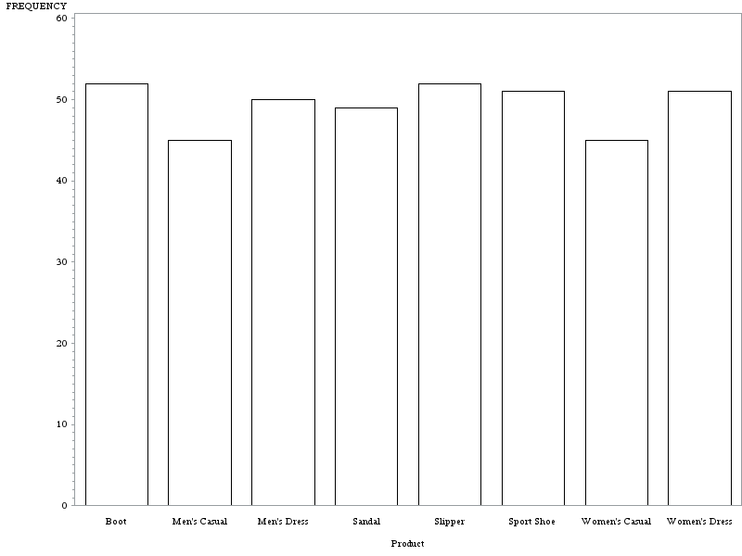

*След това създаваме кръгла графика във формата на поничка в зелен цвят:*

title "Creating a Pie Chart";

goptions colors=(green);

**proc** **gchart** data=sashelp.shoes;

DONUT product;

**run**;

**quit**;

**Creating a Pie Chart**

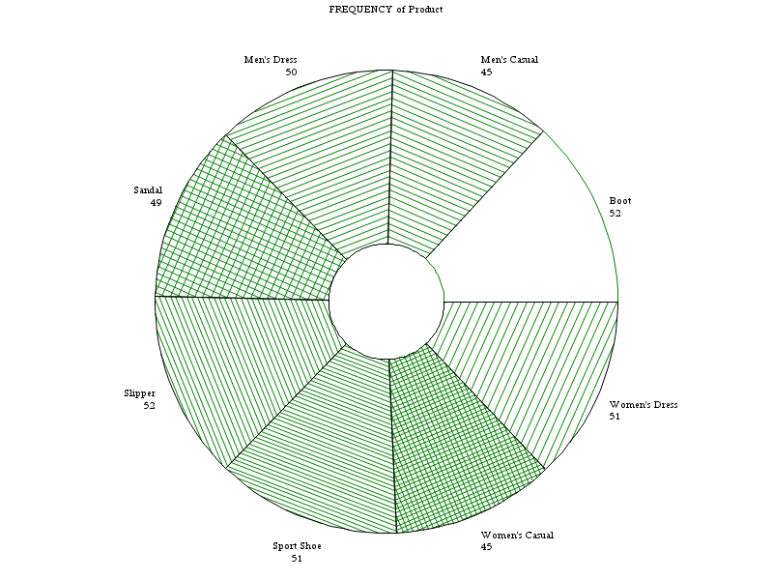

*Изтриваме пак всички предишни опции , за да направим хоризонтална 3D графика за променливата в червен цвят:*

goptions reset=all

/*resets all of the graphics options to their default values */

ftext='Times'

htext=**1.5**

ftitle='arial/bo'

htitle=**2.5**

colors=(red);

title "Distribution of product";

**proc** **gchart** data=sashelp.shoes;

hbar3d product;

**run**;

**quit**;

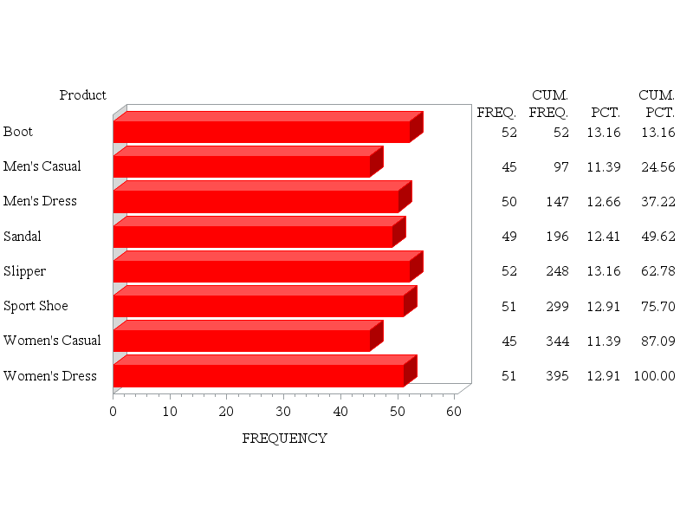

*След това правим графика , кочто илюстрира променливите SALES и INVENTORY:*

goptions reset=all;

title "Scatter Plot of sales by inventory";

title2 h=**2.2** "Interpolation methods";

symbol value=dot interpol=join ;

**proc** **gplot** data=sashelp.shoes;

plot sales * inventory;

**run**;

**quit**;

**Scatter Plot of sales by inventory**

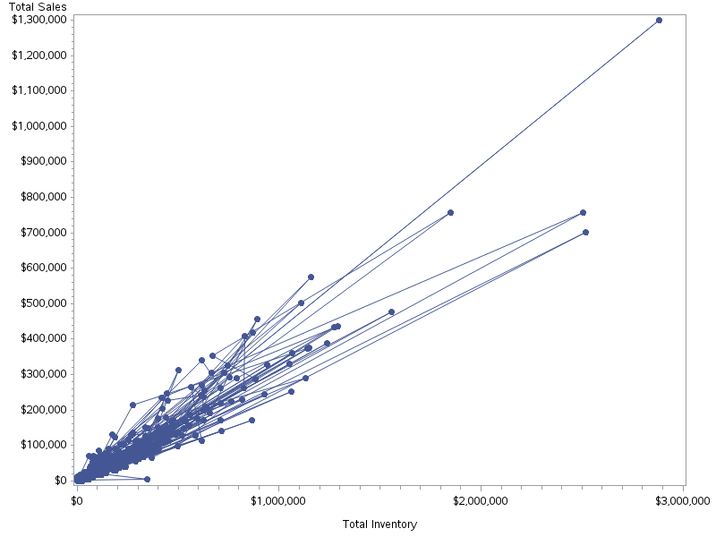

*Сортираме нашите данни по INVENTORY и запазваме файла в WORK:*

**proc** **sort** data=sashelp.shoes out=work.shoes;

by inventory;

**run**;

**proc** **gplot** data=shoes;

plot sales * inventory;

**run**;

**quit**;

**Scatter Plot of sales by inventory**

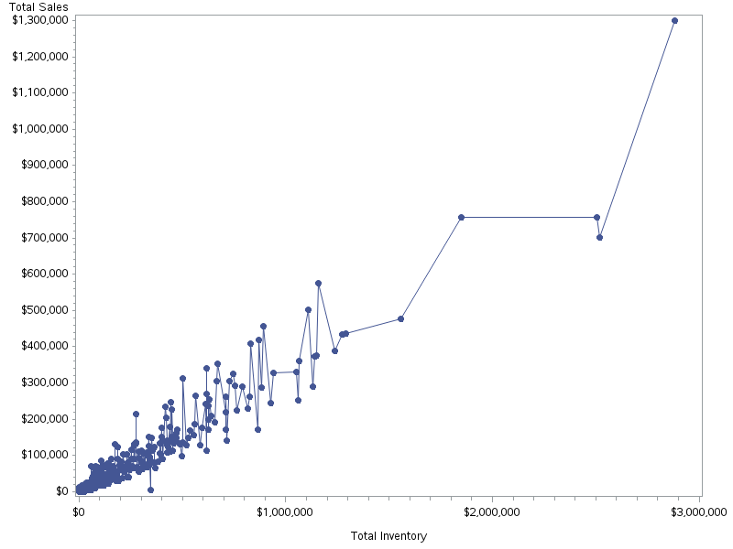

**Зад. 6** Направете анализ на зададени от вас данни.

*Създаваме файл със следните данни:*

**data** exercise;

input id exertype diet time1 time2 time3;

cards;

1 1 1 85 85 88

2 1 1 90 92 93

3 1 1 97 97 94

4 1 1 80 82 83

5 1 1 91 92 91

6 1 2 83 83 84

7 1 2 87 88 90

8 1 2 92 94 95

9 1 2 97 99 96

10 1 2 100 97 100

11 2 1 86 86 84

12 2 1 93 103 104

13 2 1 90 92 93

14 2 1 95 96 100

15 2 1 89 96 95

16 2 2 84 86 89

17 2 2 103 109 90

18 2 2 92 96 101

19 2 2 97 98 100

20 2 2 102 104 103

21 3 1 93 98 110

22 3 1 98 104 112

23 3 1 98 105 99

24 3 1 87 132 120

25 3 1 94 110 116

26 3 2 95 126 143

27 3 2 100 126 140

28 3 2 103 124 140

29 3 2 94 135 130

30 3 2 99 111 150

;

**run**;

*Изчистваме си предишно зададени опции на графиките и след това си въвеждаме желаните от нас опции:*

goptions reset=all;

symbol1 c=blue v=star h=**.8** i=j;

symbol2 c=red v=dot h=**.8** i=j;

symbol3 c=green v=square h=**.8** i=j;

axis1 order=(**60** to **150** by **30**) label=(a=**90** 'Means');

axis2 label=('Time') value=('1' '2' '3');

*правим анализ на повторени във времето измервания и получаваме:*

**proc** **glm** data=exercise;

class exertype;

model time1 time2 time3 = exertype;

repeated time **3** ;

lsmeans exertype / out=means;

**run**;

**quit**;

|  |  |  |  |  |  |  |  |  |  |  |  |  |  |  |  |  |  |  |
| --- | --- | --- | --- | --- | --- | --- | --- | --- | --- | --- | --- | --- | --- | --- | --- | --- | --- | --- |
| |  |  | | --- | --- | | |  | | --- | | **The GLM Procedure** | | | |  |  |  |  |  |  |  |  |  |  | | --- | --- | --- | --- | --- | --- | --- | --- | --- | --- | | | **Class Level Information** | | | | --- | --- | --- | | **Class** | **Levels** | **Values** | | exertype | 3 | 1 2 3 | | | | Number of Observations Read | 30 | | --- | --- | | Number of Observations Used | 30 | | | |

*От получения резултат се вижда:*

*Имаме 3 нива на упражненията и всяко ниво се именува с число 1,2,3*

*Броя на наблюденията е 30.*

**The GLM Procedure**  
  
**Dependent Variable: time1**

| **R-Square** | **Coeff Var** | **Root MSE** | **time1 Mean** |
| --- | --- | --- | --- |
| 0.158608 | 6.279252 | 5.848077 | 93.13333 |

*От тези таблица можем да видим:*

*Средната стойност на пулса при първото измерване без значение типа на упражнението-93.13333.*

*Средната стойност на пулса при второто измерване без значение типа на упражнението -101.5333*

| **R-Square** | **Coeff Var** | **Root MSE** | **time2 Mean** |
| --- | --- | --- | --- |
| 0.617295 | 9.196682 | 9.337697 | 101.5333 |

*Средната стойност на пулса при третото измерване без значение типа на упражнението -104.4333*

| **R-Square** | **Coeff Var** | **Root MSE** | **time3 Mean** |
| --- | --- | --- | --- |
| 0.684972 | 10.51416 | 10.98029 | 104.4333 |

|  |  |  |  |  |  |  |  |  |  |  |  |  |  |  |  |  |  |  |  |  |  |
| --- | --- | --- | --- | --- | --- | --- | --- | --- | --- | --- | --- | --- | --- | --- | --- | --- | --- | --- | --- | --- | --- |
| |  |  |  | | --- | --- | --- | | |  |  | | --- | --- | | **The GLM Procedure Least Squares Means** |  | | | |  |  |  |  |  |  |  |  |  |  |  |  |  |  |  |  |  | | --- | --- | --- | --- | --- | --- | --- | --- | --- | --- | --- | --- | --- | --- | --- | --- | --- | | | **exertype** | **time1 LSMEAN** | **time2 LSMEAN** | **time3 LSMEAN** | | --- | --- | --- | --- | | 1 | 90.2000000 | 90.900000 | 91.400000 | | 2 | 93.1000000 | 96.600000 | 95.900000 | | 3 | 96.1000000 | 117.100000 | 126.000000 | | | |

*Тази таблица ни дава средната стойност на пулса в зависимост от типа на упражнението поредността на измерването на пулса.*

**proc** **print** data=means;

**run**;

| **Obs** | **_NAME_** | **exertype** | **LSMEAN** | **STDERR** |
| --- | --- | --- | --- | --- |
| 1 | time1 | 1 | 90.2 | 1.84932 |
| 2 | time1 | 2 | 93.1 | 1.84932 |
| 3 | time1 | 3 | 96.1 | 1.84932 |
| 4 | time2 | 1 | 90.9 | 2.95284 |
| 5 | time2 | 2 | 96.6 | 2.95284 |
| 6 | time2 | 3 | 117.1 | 2.95284 |
| 7 | time3 | 1 | 91.4 | 3.47227 |
| 8 | time3 | 2 | 95.9 | 3.47227 |
| 9 | time3 | 3 | 126.0 | 3.47227 |

*Тази таблица показва и стандартната грешка в зависимост от типа на упражнението и поредността на измерванията.*

**proc** **gplot** data=means;

plot lsmean*_name_=exertype / vaxis=axis1 haxis=axis2;

**run**;

**quit**;

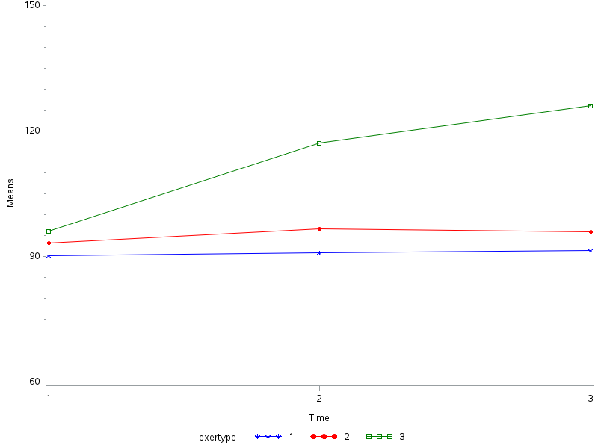

*От графиката се вижда средния пулс за всяко едно измерване за всеки вид упражнение и можем да кажем ,че най- натоварващо е третото упражнение.*

*Правим корелационен анализ за трите променливи time1 time 2 time 3:*

**proc** **corr** data=exercise cov;

var time1 time2 time3;

**run**;

|  |  |  |  |  |  |  |  |  |  |  |  |  |  |  |  |  |  |  |  |  |  |  |  |  |  |  |  |  |  |  |  |  |  |  |  |  |  |  |  |  |  |  |  |  |  |  |  |  |  |  |  |  |  |  |  |  |  |  |  |  |  |  |  |  |  |  |  |  |  |  |  |  |  |  |  |  |  |  |  |  |  |  |  |  |  |  |  |  |  |  |  |  |  |  |  |  |  |  |  |  |  |  |  |  |  |
| --- | --- | --- | --- | --- | --- | --- | --- | --- | --- | --- | --- | --- | --- | --- | --- | --- | --- | --- | --- | --- | --- | --- | --- | --- | --- | --- | --- | --- | --- | --- | --- | --- | --- | --- | --- | --- | --- | --- | --- | --- | --- | --- | --- | --- | --- | --- | --- | --- | --- | --- | --- | --- | --- | --- | --- | --- | --- | --- | --- | --- | --- | --- | --- | --- | --- | --- | --- | --- | --- | --- | --- | --- | --- | --- | --- | --- | --- | --- | --- | --- | --- | --- | --- | --- | --- | --- | --- | --- | --- | --- | --- | --- | --- | --- | --- | --- | --- | --- | --- | --- | --- | --- | --- | --- | --- |
| |  |  |  |  |  |  |  |  |  |  |  |  |  |  |  |  |  |  |  |  |  |  |  |  |  |  |  |  |  |  |  |  |  |  |  |  |  |  |  |  |  |  |  |  |  |  |  |  |  |  |  |  |  |  |  |  |  |  |  |  |  |  |  |  |  |  |  |  |  |  |  |  |  |  |  |  |  |  |  |  |  |  |  |  |  |  |  |  |  |  |  |  |  |  |  |  |  |  |  |  |  |  |  |  |  | | --- | --- | --- | --- | --- | --- | --- | --- | --- | --- | --- | --- | --- | --- | --- | --- | --- | --- | --- | --- | --- | --- | --- | --- | --- | --- | --- | --- | --- | --- | --- | --- | --- | --- | --- | --- | --- | --- | --- | --- | --- | --- | --- | --- | --- | --- | --- | --- | --- | --- | --- | --- | --- | --- | --- | --- | --- | --- | --- | --- | --- | --- | --- | --- | --- | --- | --- | --- | --- | --- | --- | --- | --- | --- | --- | --- | --- | --- | --- | --- | --- | --- | --- | --- | --- | --- | --- | --- | --- | --- | --- | --- | --- | --- | --- | --- | --- | --- | --- | --- | --- | --- | --- | --- | --- | | |  |  | | --- | --- | | |  | | --- | | **The CORR Procedure** | | | |  |  |  | | --- | --- | --- | | | 3 Variables: | time1 time2 time3 | | --- | --- | | | | **Covariance Matrix, DF = 29** | | | | | --- | --- | --- | --- | |  | **time1** | **time2** | **time3** | | time1 | 37.8436782 | 48.7885057 | 60.2850575 | | time2 | 48.7885057 | 212.1195402 | 233.7609195 | | time3 | 60.2850575 | 233.7609195 | 356.3229885 | | |  | | *Таблицата ни извежда числовите харектеристики на всяка една времева група* | | | **Simple Statistics** | | | | | | | | --- | --- | --- | --- | --- | --- | --- | | **Variable** | **N** | **Mean** | **Std Dev** | **Sum** | **Minimum** | **Maximum** | | time1 | 30 | 93.13333 | 6.15172 | 2794 | 80.00000 | 103.00000 | | time2 | 30 | 101.53333 | 14.56432 | 3046 | 82.00000 | 135.00000 | | time3 | 30 | 104.43333 | 18.87652 | 3133 | 83.00000 | 150.00000 | | | | **Pearson Correlation Coefficients, N = 30  Prob > |r| under H0: Rho=0** | | | | | --- | --- | --- | --- | |  | **time1** | **time2** | **time3** | | time1 | |  | | --- | | 1.00000 | |  | | |  | | --- | | 0.54454 | | 0.0019 | | |  | | --- | | 0.51915 | | 0.0033 | | | time2 | |  | | --- | | 0.54454 | | 0.0019 | | |  | | --- | | 1.00000 | |  | | |  | | --- | | 0.85028 | | <.0001 | | | time3 | |  | | --- | | 0.51915 | | 0.0033 | | |  | | --- | | 0.85028 | | <.0001 | | |  | | --- | | 1.00000 | |  | | | | | |
|  |

*Формулираме хипотези, където основната е: пулса не се изменя при всяко измерване.*

*Пиърсън коефициента ни показва , че отхвърляме основната хипотеза в полза на алтернативната т.е. пулсът се изменя.*